How to Become a Junior Ranger
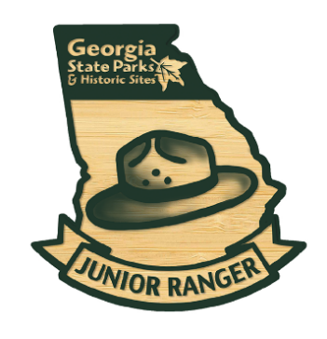
Free Junior Ranger Activity Books and reward badges are available at 59 Georgia's State Parks & Historic Sites. Children of any age can learn about history and explore the outdoors as they work toward earning 59 different site-specific Junior Ranger badges. Inside each book there are mini missions to complete to receive a badge and become a certified Junior Ranger for each park. Junior Rangers can work through the activity requirements on their own or with an adult helper.
How do I get a book? As part of an ongoing statewide effort to prevent the spread of COVID-19, Park Staff is providing assistance by phone and web-based resources rather than in-person assistance. We apologize for the inconvenience. If you would like to get a free Junior Ranger book, please call: _________________ for assistance.


How can I get my reward and be sworn in as an official Junior Ranger? If you have completed your book and would like to receive your free badge and have a park ranger swear you in, please call the number listed above. If a ranger is available, they will be here soon. During peak visitation times all park rangers may be assisting with directing traffic, cleaning bathrooms or assisting other guests. If a ranger is not available, you can scan the QR code to take a virtual Junior Ranger pledge and we will make arrangements to either have the badge or reward sticker left for you at the _________________Fill in blank
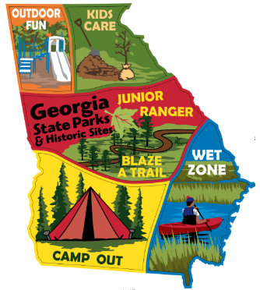
Continue Earning Rewards: Junior Rangers can continue earning additional rewards by participating in other outdoor activities. Junior Rangers can earn up to 5 other embroidery stickers once they complete activities related to park experiences like camping, fishing, swimming, paddling, volunteering, hiking and biking.



